**Deploy your Website with GitHub**

1. Make a GitHub account 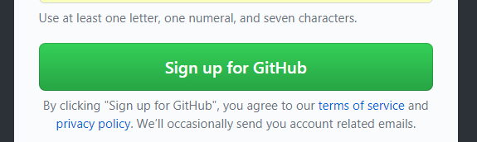

Or sign in to your GitHub account.

2. Click Start A Project  or 

And now you should see this screen

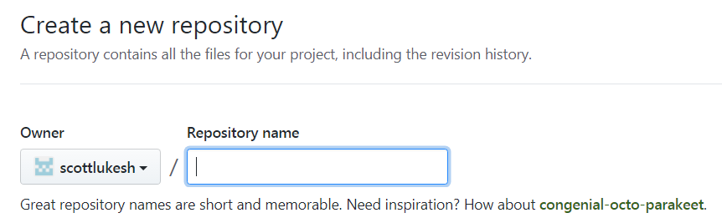

3. Give your Repository a name like csp2017

4. Be careful you **must** check the box 

5. Now click .

6. Go to settings 

7. Scroll down and change GitHub Pages to master branch.

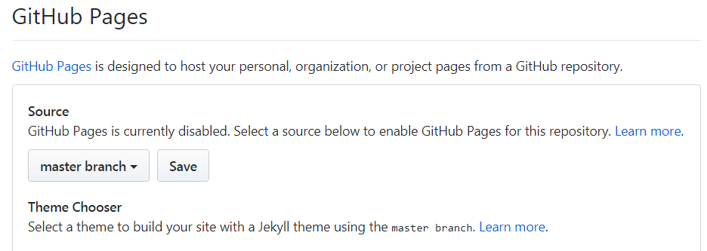

And then click Save

8. Click on code



9. Download your files from Cloud9 to a folder, it is easiest to right click on your my_website folder in cloud9 and then download. This will download a zip file, unzip the folder.

10. Click on Upload files

And drag and drop your files into 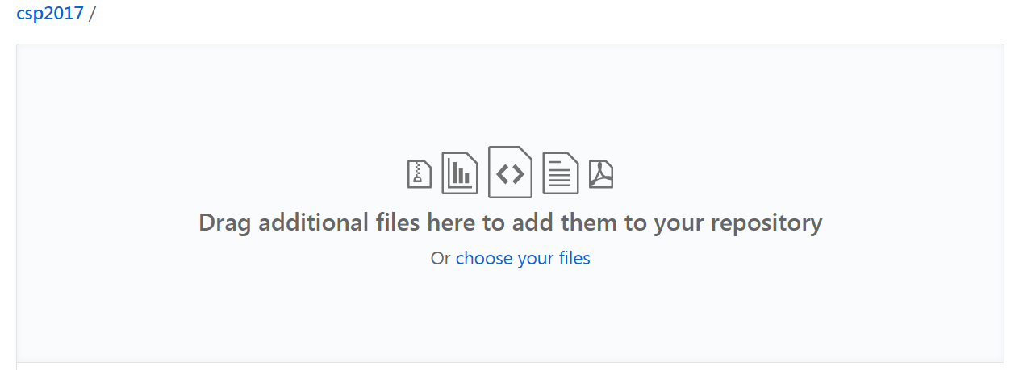

And click on commit changes 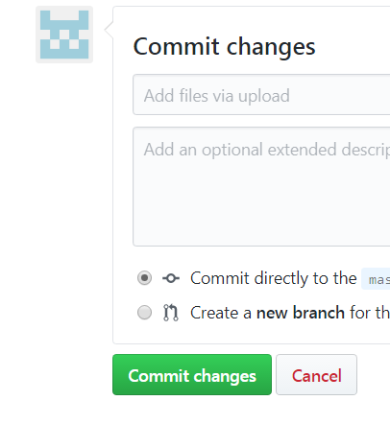

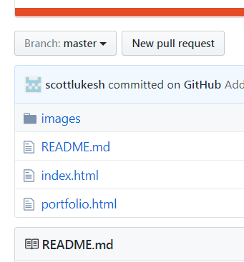

Now you should see your added files.

11. Click on setting 

And scroll down to GitHub Pages

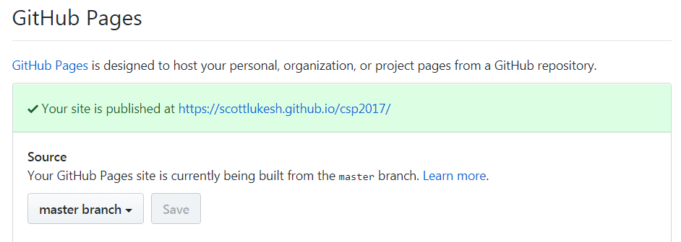

And you should see your website's address, click on it to see your live website!

12. To update your website make the changes in cloud9 and then redo step 8-10.